## Transformation Maps

The process of **masking data** using **GT Datamaker** and **GT Subset** is called **inflight masking**. Datamaker is used to create **transformation maps** and GT Subset is used create scrambled subset scripts.

**Note:** Ensure tables in target database are empty.

**1. Steps to create Transformation maps:**

1. Launch **GT Datamaker.**
2. In the tool select/create **project, version, data group, data set, data pool** respectively.
3. In the toolbar, Select **Projects** and click **Transformation** **Maps** in the drop-down list.
4. **Register** the tables on which transformation needs to be created.
5. Click the **green plus icon** to add a new Transformation Map, or select existing maps from the drop-down list. The Transformation Maps window opens.

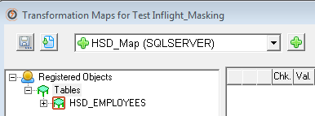

1. To insert a new row in which to enter the new map, click the **green plus icon** on the right. Enter the name of the transformation map, select DBMS from drop-down and enter the description, save it.

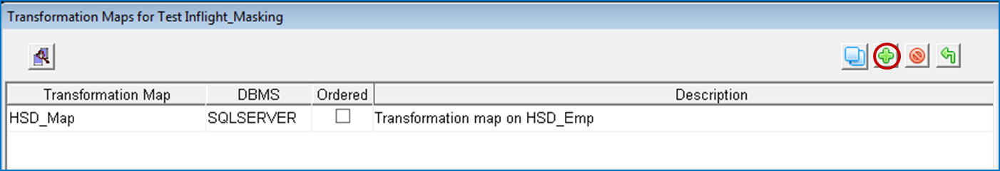

1. To create masking rules, select the drop-down and enter the rules into the Transformation column.

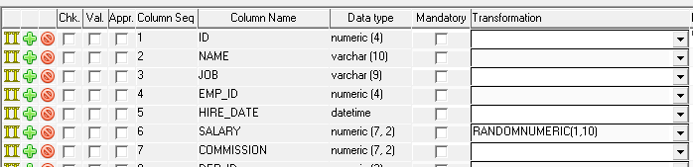

1. Click on the save icon to save the rules to file.

**2. Create subset definition and scrambled extract**

1. Launch **GT Subset**.
2. Select appropriate project, version, tables and schema.

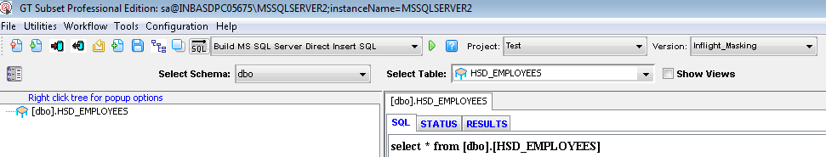

1. Create subset definition by writing the **sql query** and save extract to repository.

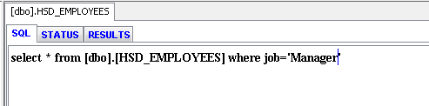

1. Select **database action** as **Build MS SQL Server Scrambled Extract** from drop-down and click on **green play** button.

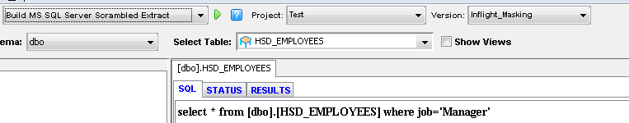

1. Create export/import batch files by giving appropriate action name, select functional database along with source and target db.

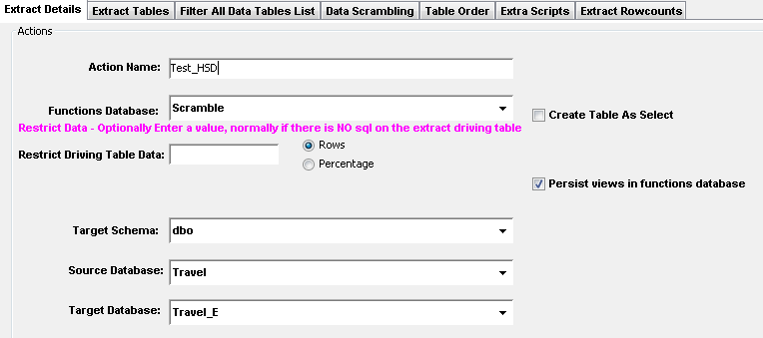

1. Proceed to next tab i.e extract tables and select the extract saved.

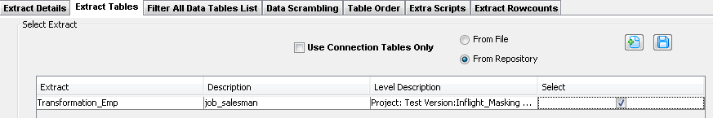

1. Subsequently move to Data Scrambling tab and choose the transformation map created.

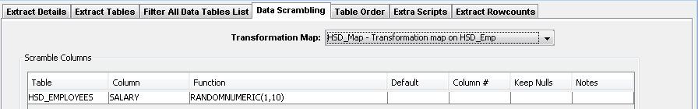

1. Verify all the tabs and proceed to generate the scrambled scripts.

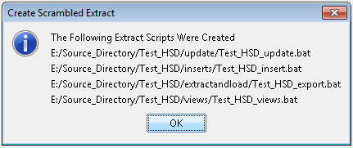

1. Navigate to the path where export/import batch files are created and open command prompt to run this files.
2. First run export batch command to export the masked data from source db.

Command as follows: **<Batch file name_export.bat> < Username> <Password> <server name> <Source db name>**

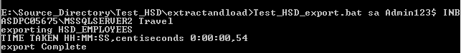

1. Now run import batch command to import the masked data to target db.

Command as follows: **<Batch file name_import.bat> < Username> <Password> <server name> <Target db name>**

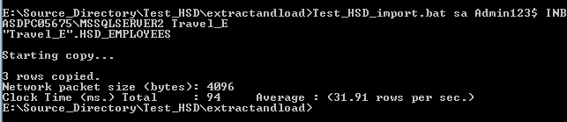

Data before masking in source database **Travel**

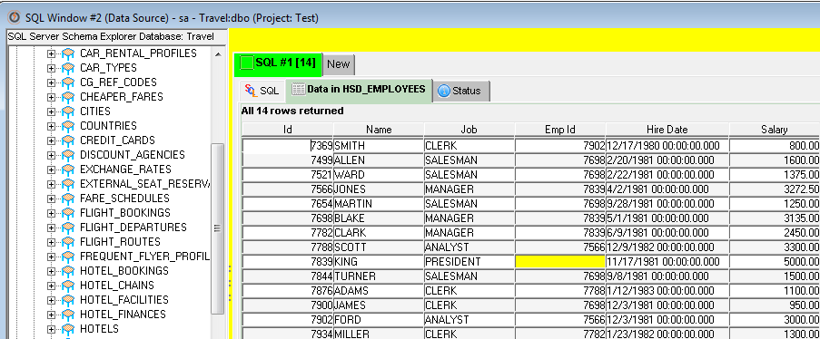

Masked data in target database **Travel_E.**

